MATH 341 Minitab Demonstration -- Lab 2 M. Blanco

1. What are the measurements of central tendency (mean, median, mode)?

The distribution for Site 1 is right skewed because the mean is greater than the mean.

|  |  |
| --- | --- |
|  |  |

The distribution for Site 2 is right skewed because the mean is greater than the mean.

|  |  |
| --- | --- |
|  |  |

1. What are the measurements of variability (range, standard deviation, variance)?

Site 2 has a larger range, standard deviation and variance compared to Site 1.

|  |  |
| --- | --- |
|  |  |

1. What is the five-number-summary (min, Q1, median, Q3, max)?

|  |  |
| --- | --- |
|  |  |
|  |  |
|  |  |

1. What is the IQR of the data?

|  |  |
| --- | --- |
|  |  |

1. What is the interval that includes the middle 95.44% of the data? How about 99.73%? You can use calc feature to calculate intervals.

|  |  |  |  |
| --- | --- | --- | --- |
| Low 95.44 | High 95.44 | Low 99.73 | High 99.73 |
| -102.445 | 676.545 | -297.193 | 871.293 |



1. What is the shape of the distribution, left skewed or right skewed (use histogram)?

The distribution for Site 2 is right skewed because the mean is greater than the mean.

1. 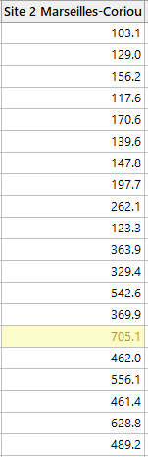Are there any outliers? If so, please list both normal and extreme outlier(s). Normal outliers are between 2 and 3 standard deviations from mean; extreme outliers are more than 3 standard deviations from mean. 